Veterinary consent form

One of your clients has requested physiotherapy treatment for their horse/dog. To indicate consent please complete the following form and email/paper copy to return. I can be contacted on the number or email above if you wish to discuss the case. Thank you.

Owner’s Details

|  |  |
| --- | --- |
| Name: |  |
| Address: |  |
| Telephone: |  |
| Email: |  |

Animal’s Details

|  |  |  |  |
| --- | --- | --- | --- |
| Name: |  | | |
| Age: |  | Sex: |  |
| Breed: |  | Colour: |  |

I declare I am the legal owner of the named animal above and to the best of my knowledge all the information provided is correct. I give consent for Gina Cook to treat my animal with physiotherapy and to discuss details of treatment with my veterinary surgeon.

Owner Signature: ……………………………………………Print Name:………………………... Date:

**Your veterinary surgeon should complete the sections below and sign.**

Medical History

|  |  |
| --- | --- |
| DETAILS OF PRESENT HEALTH CONDITION AND VETERINARY MANAGEMENT |  |

I consent to this animal to have physiotherapy treatment, including the use of electrotherapies when appropriate. I understand that the provision of professional indemnity insurance for this is the responsibility of Gina Cook.

|  |  |  |  |
| --- | --- | --- | --- |
| Practice:  Name & Address |  | | |
| Telephone: |  | | |
| Email: |  | | |
| Vets Name (print): |  | | |
| Vets Signature: |  | Date: |  |

**Please tick:**

I would like a follow up report from every session: [ ] Follow up report at every 3/6 session (unless a problem was found): [ ]

Gina Cook

BSc Veterinary physiotherapist

16 Rufford Close Guisborough,

TS147PU

Email: ginacook1997@live.com

07964810075

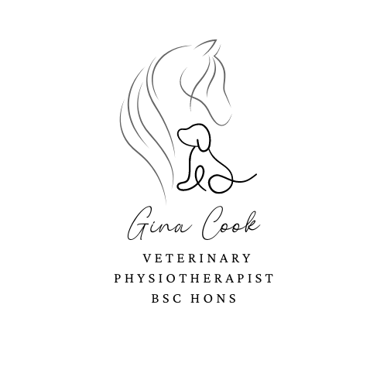

Covering the Northeast of England

Qualified in Veterinary Physiotherapy BSc

Qualified in Therapeutic Massage for Animals

Registered with IRVAP

Fully Insured.

.